PRACTICAL 7 & 8
Part A (To be referred by students)

Built-in functions and User Defined Functions
SAVE THE FILE AND UPLOAD AS (RollNo_Name_Exp7&8)
Aim: To understand and apply built in and user defined functions in Python programming and explore their usefulness in solving problems.

Problem Statement:
Solve the following computational problems by recognizing python data structure and apply them to implement following programs

User defined functions
- Implement program using user defined function to check year is leap or not. A year is a leap if it is divisible by 4 and centennial years (years divisible by 100) are leap years only when they are divisible by 400.
- Define a function ExtractEven(List) to return all even number from a list. Example l1[1,2,3,4,5,6] method should return [2,4,6].
- Write a function that returns add, sub, mul and division of two numbers.
- Define a user defined function to find area of circle or triangle. If one parameter is passed the given function finds the area of circle, if two parameters are passed the same function finds the area of triangle. You have to defined only one parameterized function which accepts either one parameters or two parameters to find area.
- Write a program to find largest number using variable length argument. (if two parameters are passed it will find largest of two, if three passed it will find largest of 3 and so on …)
- Implement a program to demonstrate **kwargs
- Write a program to print Fibonacci series upto n using recursion
- Define a recursive function find_max(lst) that returns the maximum value in the list lst.
- Create a recursive function string_length(s) that returns the length of the string s.
- Define power(base, exp) that calculates base raised to the power of exp using recursion.
- Write a recursive function print_pattern(n) that prints a pattern of * in n rows.
- Create a recursive function factorial(n) that returns the factorial of n.
- Write a function that merges two dictionaries. The merger should handle cases where the dictionaries have overlapping keys by storing values in a list. If a key exists in both dictionaries, the value in the resulting dictionary should be a list containing the values from both dictionaries.

Built-in Functions
- Write map function to return a list of numbers which are square of first 10 Fibonacci numbers.
- Write a lambda function for adding 26 to its argument, also create a lambda function that multiplies argument x with argument y and print the result.
- Write program using lambda function to display numbers divisible by 9 from the given the list
- A twitter database is given in which we have username and tweets.
users = [ {"username": 'seema', "tweets": ["i love chocolate", "i am a student"]},
{"username": 'arush', "tweets": []}, {"username": 'kumal', "tweets": ["India", "Python"]}, {"username": 'sam', "tweets": []}, {"username": 'lokesh', "tweets": ["i am good"]}, ]
i) Filter out Users which don’t have any tweets/Inactive Users
ii) Filter inactive users with just username in uppercase.
iii) Return a new list with the string “your name is” + name, but only if length of name is bigger than 4 using map , filter and Lambda

names=['Rohan','Rhea','bob','to']
Output:['your name is Rohan', 'your name is Rhea']

Topic covered: User Defined Functions and Built in functions

Learning Objective: Learner would be able to
- Learn how to define, and invoke user defined functions
- Apply user defied/ built in functions to solve problems
- Work on recursion.

Theory:

- Functions are sub program & in Python, interpreter creates an object of function internally.
- Functions are used to perform a specific task
- If there are several tasks, one can write multiple functions
- When we define function inside a class, it is called as method.
- ‘def’ keyword is used to define functions
- Syntax of function definition:
def functionname(parameter list):
#function body
- A functions can not executes its own, it needs to call/invocation when required.
- Function is called using its name and passing values if any.
- Syntax:
functionname(value/values)

Example:-
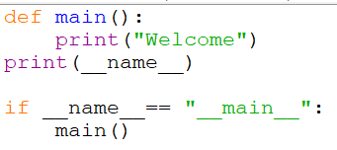

- It is also possible to return values back to the calling place from function.
- Return is used to send value back to calling place.

- Advantages of Functions:-
  - Reusability
  - Easy to maintain and write
  - Easy to debug
  - Functions provides modularity(part of a program) for programming & work distribution is possible

Retuning Values:-
- In Python’s function, we can send one or multiple values back to calling place
- If return is not used in function, it will send None back to the calling place
- Return can send one or multiple values back to the calling place
  - Example.

  - Returning None
def fun():
print(1)
a=fun()
print(a)

  - Returning only one Value
def fun():
return 10
a=fun()
print(a)

  - Returning Multiple Values
def fun():
return 1,2,3,4
a=fun() #a,b,c,d=1,2,3,4
print(a)
  - Multiple Values are return in form of a tuple…

Pass by Objects

- There are various function calling mechanisms like
  - Call/pass by Value
  - Call/pass by Address
  - Call/pass by Reference
- But, Python programming supports call/pass by object.
- Because, everything is considered as object in Pyhon.
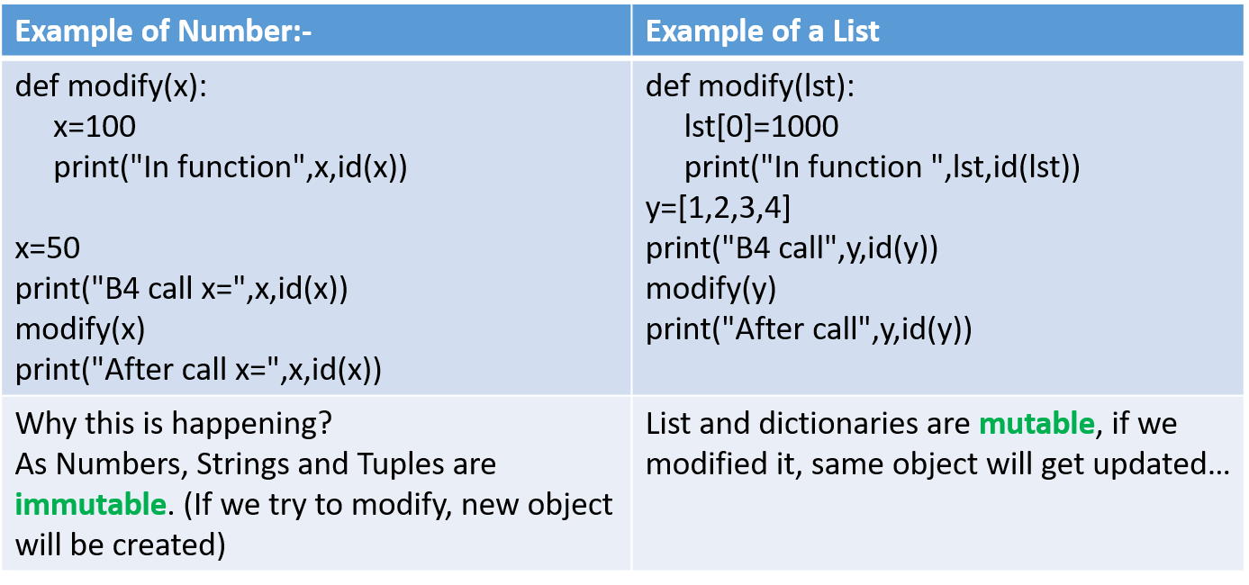

Arguments:-
  - Formal Arguments/Parameters
  - Actual Arguments/Parameters
  - Following Types of Arguments are supported by Functions in Python.
    - Positional Arguments
    - Keyword/named Arguments
    - Default Arguments
    - Variable Length Arguments
Recursion:-
- A Function having call to itself.
- Example:
def fun():
fun()
fun()

Variable Length Argument(varargs):
- You can specify arbitrary number of arguments(varargs).
- Variable length argument
  - function(farg, *args)
    - Args is implicit tuple
- Keyword variable length argument
  - function(**kwargs)
    - Kwargs is implicit dictionary
    - Example:
def fun(**kwargs):
print(kwargs)
fun(a=2,b='3',c='4')

Built-in Functions:-

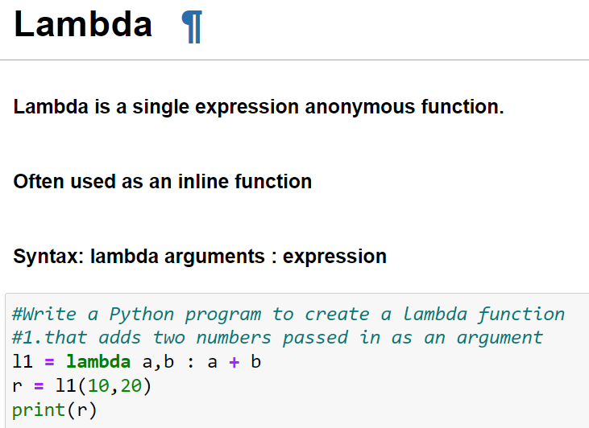

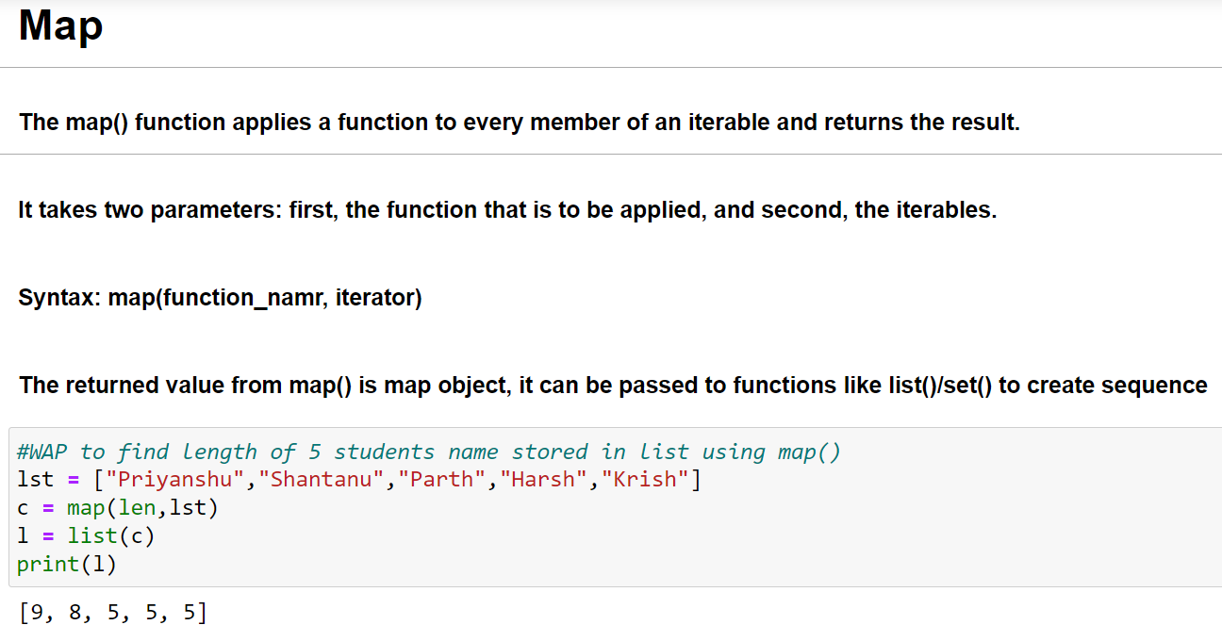

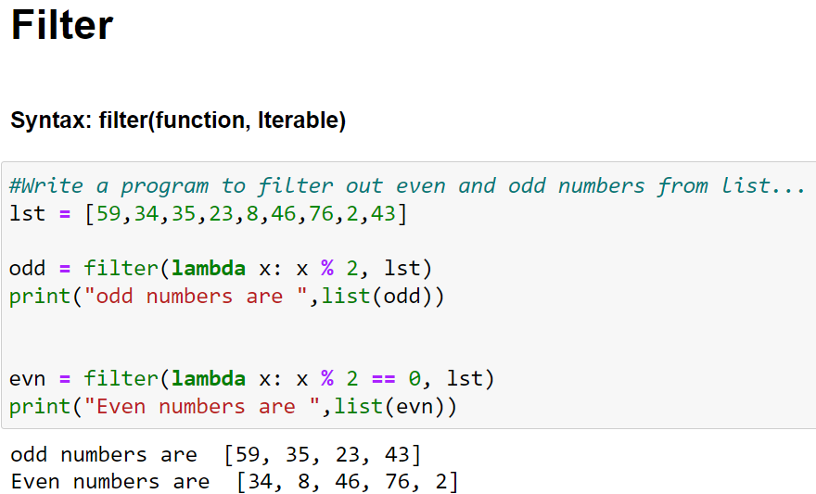

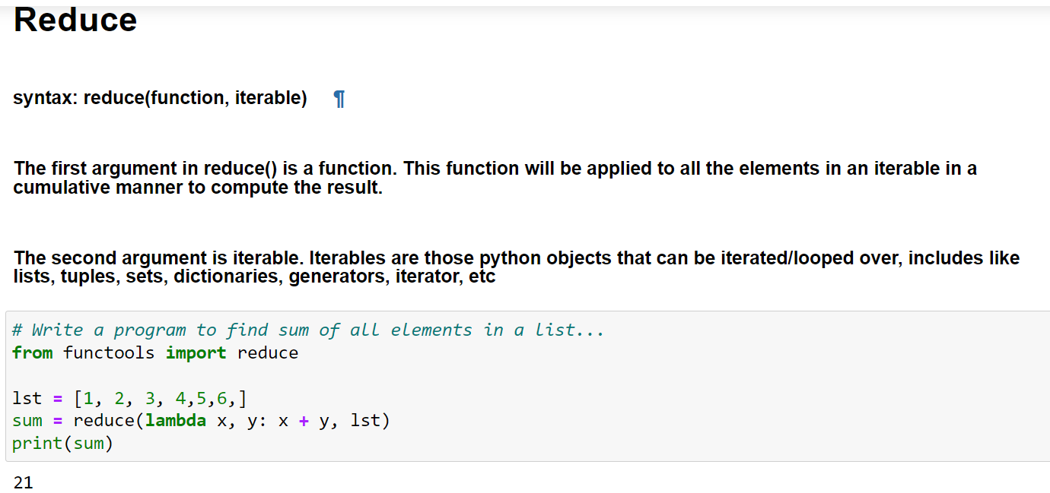

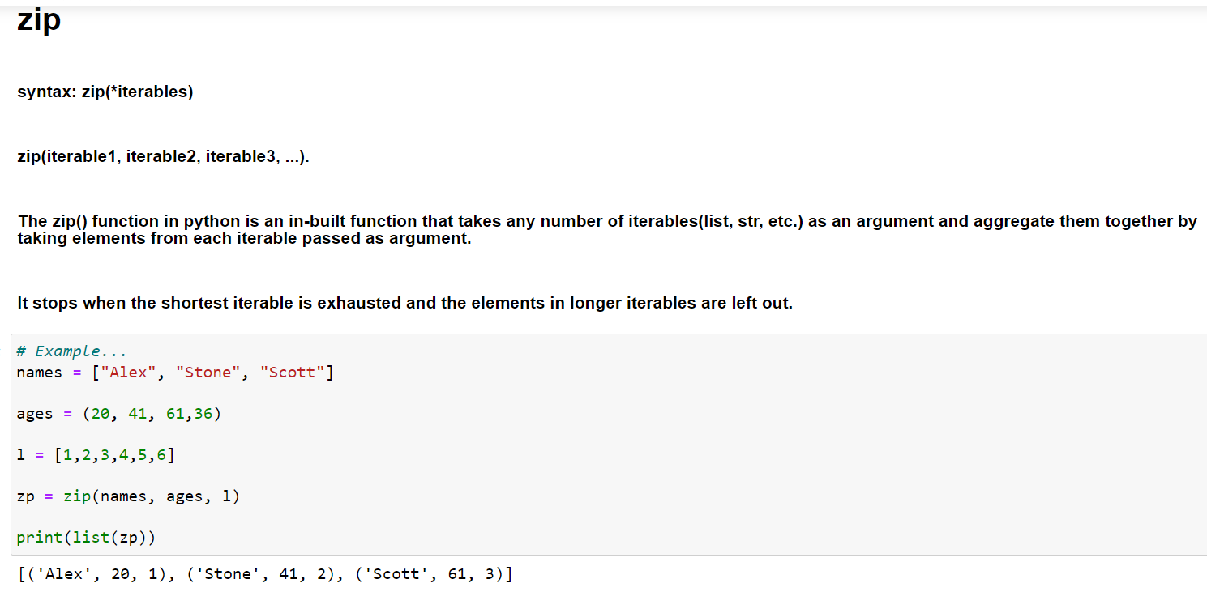

PRACTICAL 7
Part B (to be completed by students)

Built-in Functions & User Defined Function

- All the students are required to perform the given tasks in Jupyter Notebook
- Create a new notebook for each experiment. The filename should be RollNo_Name_Exp7)
- In the first cell, the student must write his/her Name, roll no and class in the form of comments
- Every program should be written in separate cells and in the given sequence
- After completing the experiment, download the notebook in pdf format. The filename should be RollNo_Name_Exp7.pdf).
Note: - To download as a PDF, go to File and choose Print Preview. This will open a new tab. Now, press Ctrl + P and opt to save as PDF.
OR
Download notebook as HTML and open downloaded html(webpage), press CTRL+P and opt to save as PDF.
- Upload the pdf on the web portal

For Understanding::

def sum(a,b)
if a>10:
return a+b
else :
return a+b+100
print(sum(10,20))

newsum=lambda a,b: a+b
print(newsum(10,20))

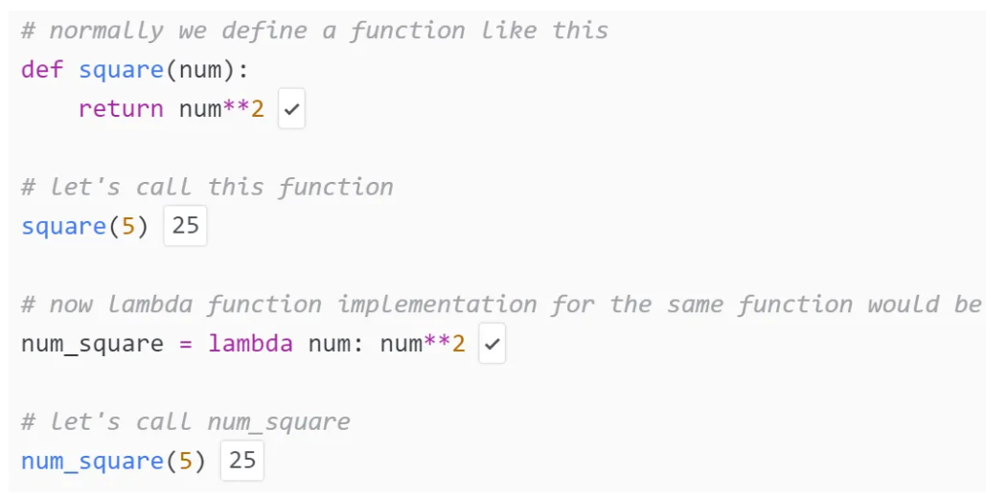

ids=[20,30,40]
name=[‘Ram’,”lakshman’,”Sita’]
record=dict(zip(ids,name))

……………………..

def xyz(n):
return n*n
l=[2,4,7]
c=map(xyz,l)
print(list(c) )

………………………………………………

d= lambda n:n*n
l=[2,4,7]
c=map(d,l)
print(list(c) )

filter(a,b) // a function apply on b sequence

Reduce

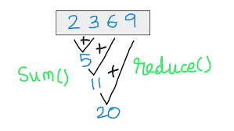

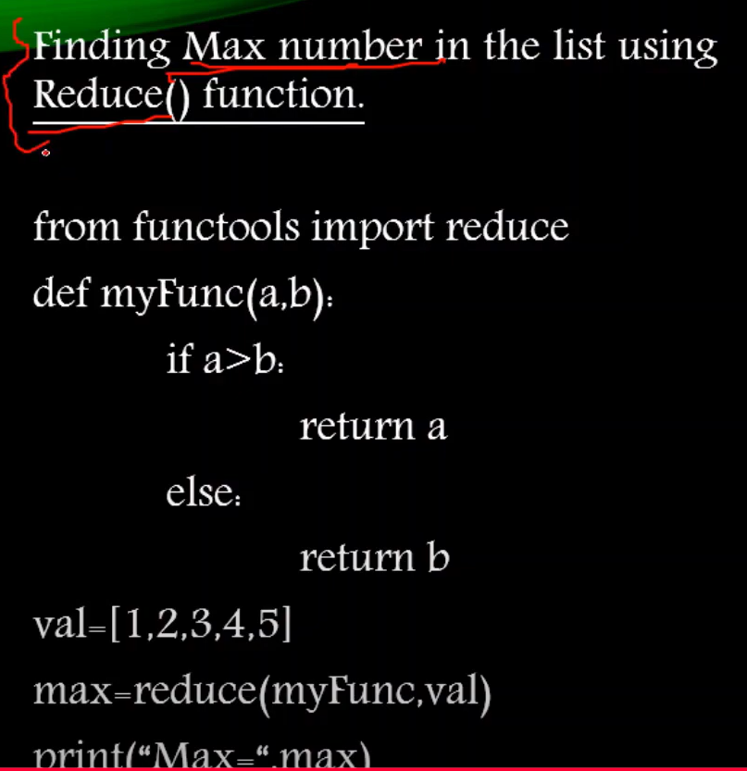

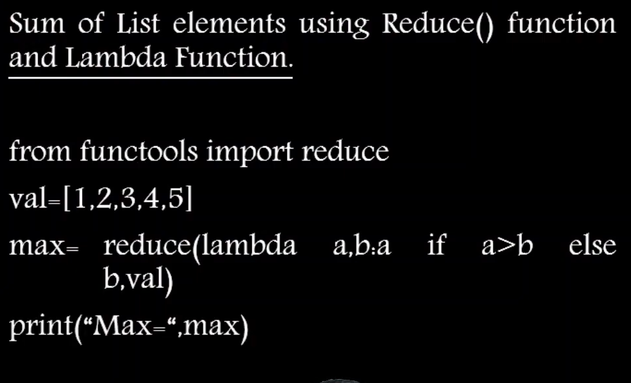

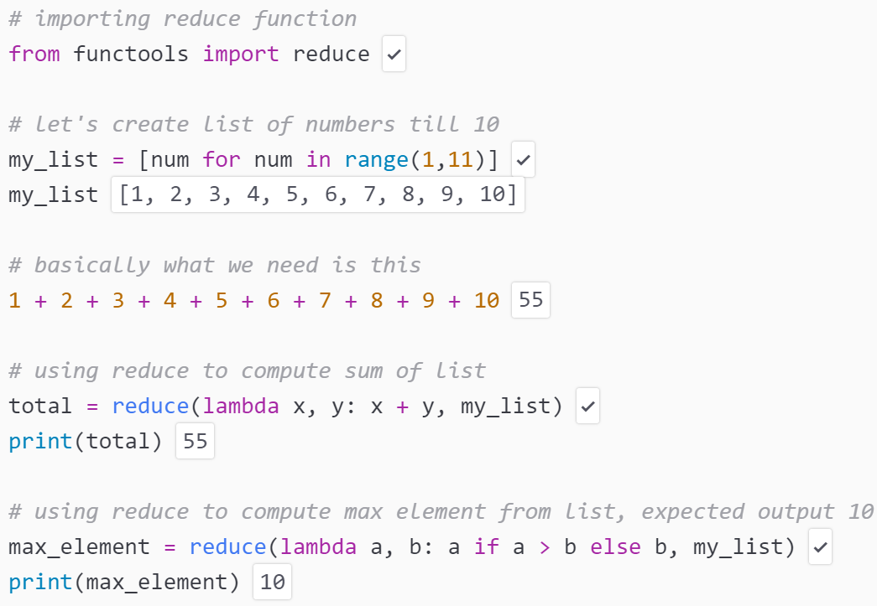

Filter , Map, Reduce Functions

Huge Data Filter () small Data Map() change in data reduce() reduced data

